# Silk Home Assignment

## Introduction

This assignment is intended to provide you a taste of what we are building here in Silk and allow you to experiment with some of the concepts you will encounter in your day to day job.

*If you don’t have enough time or are having difficulties completing this assignment, just make sure you provide us with how you approached the problem and what your next steps would have been.*

## 

## Instructions

### Context

We have provided you with a sqlite db file (*findings.db),* which was scraped by our backed system from an actual Jira system!

Each Jira ticket was converted to a “**Raw Finding**”.  
Raw findings include information from the ticket such as:

* when it was created
* what security tool generated this ticket
* what is the current status of the ticket, etc…

Silk groups raw findings are grouped together to form a “**Grouped Finding**”.

*The grouping technology is not a part of the exercise.*

The assignment is composed of three parts

1. Backend API - designing an API to be queried by the front end code
2. ORM - connect the db with the API
3. Frontend

Use **typescript / react** for the frontend, and  **node / typescript** for the backend.

(tailwind/mongo is recommended but not a must 🙂)

I provided a few examples of how the visualization might look (in the exercise section below) - but please **don’t** try to replicate them as is.

### 

### 

### Exercise

You are tasked with creating a single web page that has the following components:

* A dashboard layout (that makes sense) with the following widgets:
  + A ***collapsible* table** to display the grouped findings
    - When click it expands to the raw findings within that group (example below):

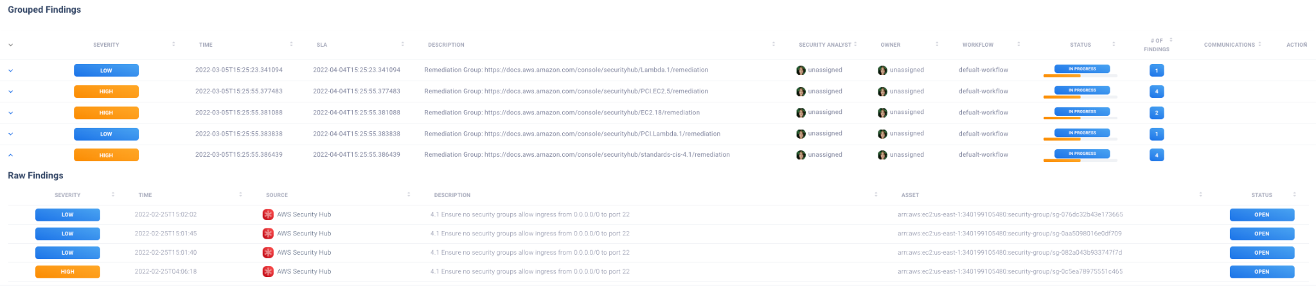

* A **pie chart** of grouped findings severity (example below)

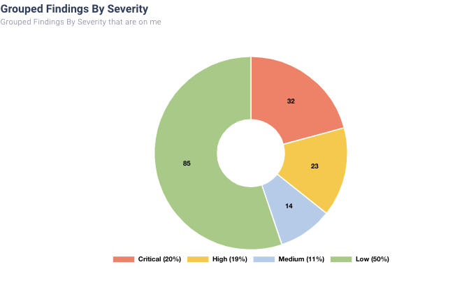

Please submit the exercise to bar@silk.security after 7 days of receiving it.

## 

## Tips

* Pay attention to design decisions, and coding decisions. Think about how you would actually build this system in a scalable/robust way.
* Visualization is important
* Try to clean the code from any leftovers of boilerplate code when copying from a 3rd party template.
* Easiest way to submit is sharing a **private** github repo with bar@silk.security with clear instructions on how to run the code.
* Please use **react with typescript** 🙂

Lastly, we will review and discuss the exercise in person after the submission - and even make a few changes together :)

***Good luck!***

***Questions?***

*Email me: bar@silk.security*